**Date:** 8th FEB 2017

**Reg. No.:** 14BIT004

**Experiment No:** 1.2

**Question:** Study of Network Devices in detail. *Repeater, Hub, Switch, Bridge, Route, Gate Way*

Types of networking devices,

1. Hub,
2. Repeater,
3. Switch,
4. Bridge,
5. Router,
6. Gate Way.

**HUB (Layer 1):**

Network Hub is a networking device which is used to connect multiple network hosts. A network hub is also used to do data transfer. The data is transferred in terms of packets on a computer network. So when a host sends a data packet to a network hub, the hub copies the data packet to all of its ports connected to. Like this, all the ports know about the data and the port for whom the packet is intended, claims the packet.

However, because of its working mechanism, a hub is not so secure and safe. Moreover, copying the data packets on all the interfaces or ports makes it slower and more congested which led to the use of network switch.

HUB

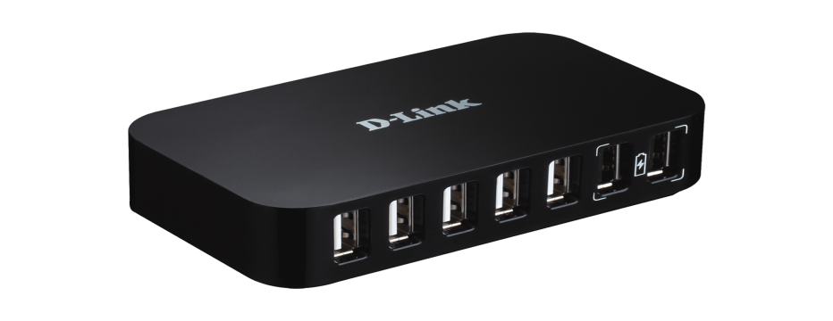

**REPEATER (Layer 1):**

A repeater is an electronic device that amplifies the signal it receives. In other terms, you can think of repeater as a device which receives a signal and retransmits it at a higher level or higher power so that the signal can cover longer distances.

REPEATER

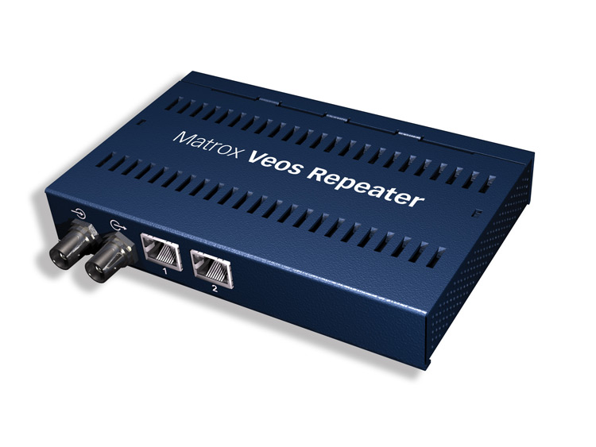

**SWITCH (Layer 2):**

Like a hub, a switch also works at the layer of LAN (Local Area Network) but you can say that a switch is more intelligent than a hub. While hub just does the work of data forwarding, a switch does ‘filter and forwarding’ which is a more intelligent way of dealing with the data packets.

So, when a packet is received at one of the interfaces of the switch, it filters the packet and sends only to the interface of the intended receiver. For this purpose, a switch also maintains a CAM (Content Addressable Memory) table and has its own system configuration and memory. CAM table is also called as forwarding table or forwarding information base (FIB).

SWITCH

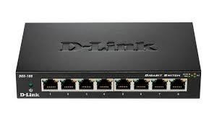

**BRIDGE (Layer 2):**

A bridge is a product that connects a local area network (LAN) to another local area network that uses the same protocol (for example, Ethernet or token ring). You can envision a bridge as being a device that decides whether a message from you to someone else is going to the local area network in your building or to someone on the local area network in the building across the street. A bridge examines each message on a LAN, "passing" those known to be within the same LAN, and forwarding those known to be on the other interconnected LAN (or LANs).In bridging networks, computer or node addresses have no specific relationship to location. For this reason, messages are sent out to every address on the network and accepted only by the intended destination node. Bridges learn which addresses are on which network and develop a learning table so that subsequent messages can be forwarded to the right network.

BRIDGE

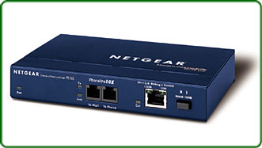

**ROUTER (Layer 3):**

A router is a network device which is responsible for routing traffic from one to another network. These two networks could be a private company network to a public network. You can think of a router as a traffic police who directs different network traffic to different directions.

ROUTER

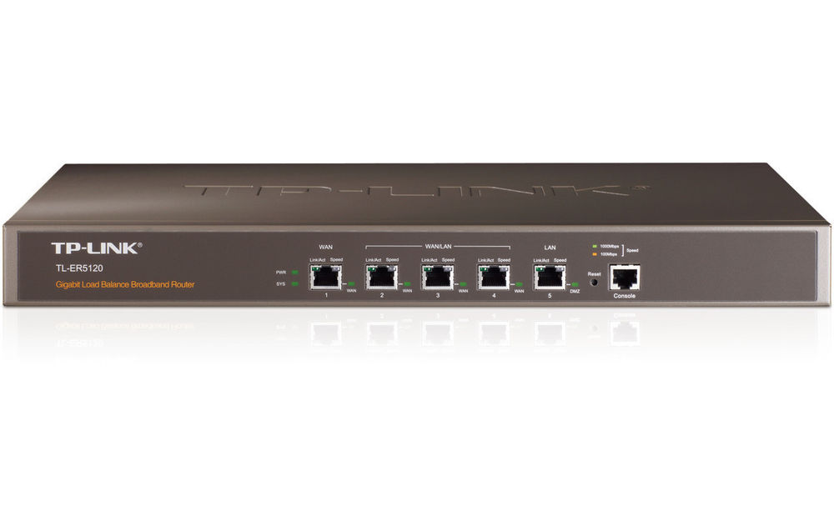

**GATEWAY (Layer 3):**

Gateway is used to forward the packets which are intended for remote network from local network. Till host is configured with default gateway address, every packet should have default gateway address. A default gateway address is the address of gateway device. If packet does not find its destination address in local network then it would take the help of gateway device to find the destination address in remote network. A gateway device knows the path of remote destination address. If require, it also change the encapsulation of packet so it can travel in other network to get its destination address.